Name:__________________________________ Date: _______________ Period: ______________
Quiz 1.1 Domain & Range Quiz A
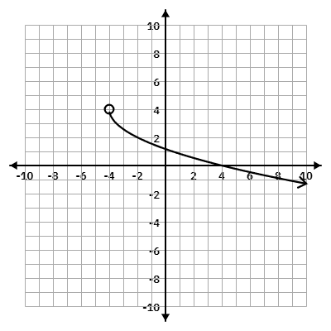
1. Write the domain and range of the function below.
Domain Inequality:_______________________

Domain Set Notation: ____________________

Domain Interval Notation: _________________

Range Inequality:_______________________

Range Set Notation: ____________________

Range Interval Notation: _________________

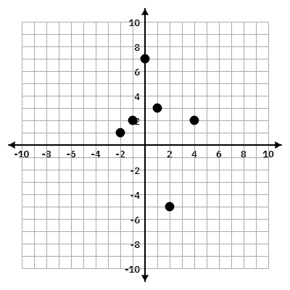
2. What is the Range of the following graph?

3. Does the graph in #2 represent a function? Justify your answer.

Bonus:
Imagine a function, f(x), that models the height of a bouncing ball over time. The ball is dropped from a height of 10 feet and each bounce reaches 75% of the previous height.
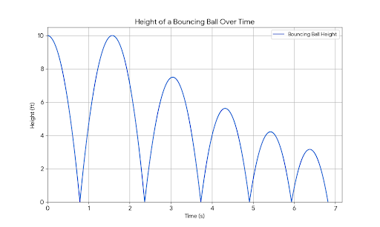
Given this scenario, what is the most appropriate domain and range for the function? Justify your answer by considering the physical limitations of the real-world situation.

